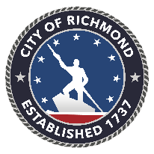

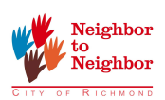
Volunteer Job Description Form

- Department/Organization: City Council – Office of The Honorable Michael Jones
- Event: Thanksgiving Turkey Giveaway
- Website: https://www.eventbrite.com/e/councilman-michael-jones-thanksgiving-turkey-giveaway-registration-51659159938

Location (please list additional work sites & pertinent info if volunteers will serve at more than one location):

Southside Community Center
6255 Old Warwick Road, Richmond, Virginia 23224

Volunteer Position:

Turkey Handout

Volunteer Job Duties:

Hand out turkeys to those receiving them. The turkeys will be frozen and in a refrigerated truck; volunteers will work together to pass turkeys from the truck to the recipient.

Skills Required:

Team work, ability to lift and carry 15-20 lbs. short distances for duration of shift.

What to wear and bring (i.e., gloves, water):

What to bring: Gloves, water, snack or lunch if working through more than 1 shift.
What to wear: Wear comfortable shoes and clothing. Be sure to bring a jacket or sweat shirt and pay attention to the weather as this role will be partially or fully outside depending on your position in the hand out line.

Project Date
Saturday, November 17, 2018
Start Time End Time # of Volunteers Needed

Shift #1 11:30 AM 1:00 PM 10
Shift #2 1:00 PM 2:30 PM 10
Shift #3 2:30 PM 4:00 PM 10
Shift #4 4:00 PM 5:30 PM 10

Contact Person(s): Contact E-mail(s) Contact Phone(s)
Summer Morris Summer.Morris@Richmondgov.com 804-646-2779
______________________________________________________________________________

(Note: If you are not a city department/agency please include
your LOGO in a jpeg or similar format to help market this opportunity)

